Track 1: Agentic Data Engineering (trial run)

In this track you'll build an agentic data system end-to-end — from programming Otto with custom rules and agents, to building a carbon-optimized operations scheduling pipeline, to wiring up automation that keeps everything running.

In this lab, you'll help GreenTech Manufacturing tackle a critical sustainability challenge facing their five UK production facilities. The company consumes over 42 million kWh annually running energy-intensive operations, and with UK carbon offset costs at £50/ton CO2, their environmental impact is becoming a significant financial burden. The key insight: the UK's electricity grid carbon intensity swings dramatically throughout the day. Your mission is to build an intelligent forecasting system that learns from 30 days of historical weather and carbon data to predict these low-carbon windows up to 7 days in advance, then identifies which flexible operations can be strategically shifted from high-carbon hours to clean-energy windows.

Lab 2: Programmatic Agentic Systems

In this lab, you'll program Otto — Ascend's AI agent to shape how it behaves. You'll build the foundation for agentic data operations for an enterprise manufacturing business: creating rules, commands, and agents that customize agentic behavior and outputs. By the end, you'll have a configured agentic harness ready to power the full pipeline build in Lab 3.

Step 1: Explore the otto/ directory
Explore file system – you can see the agents, command, rules. You can also ask otto to explain the audit_rules for example:

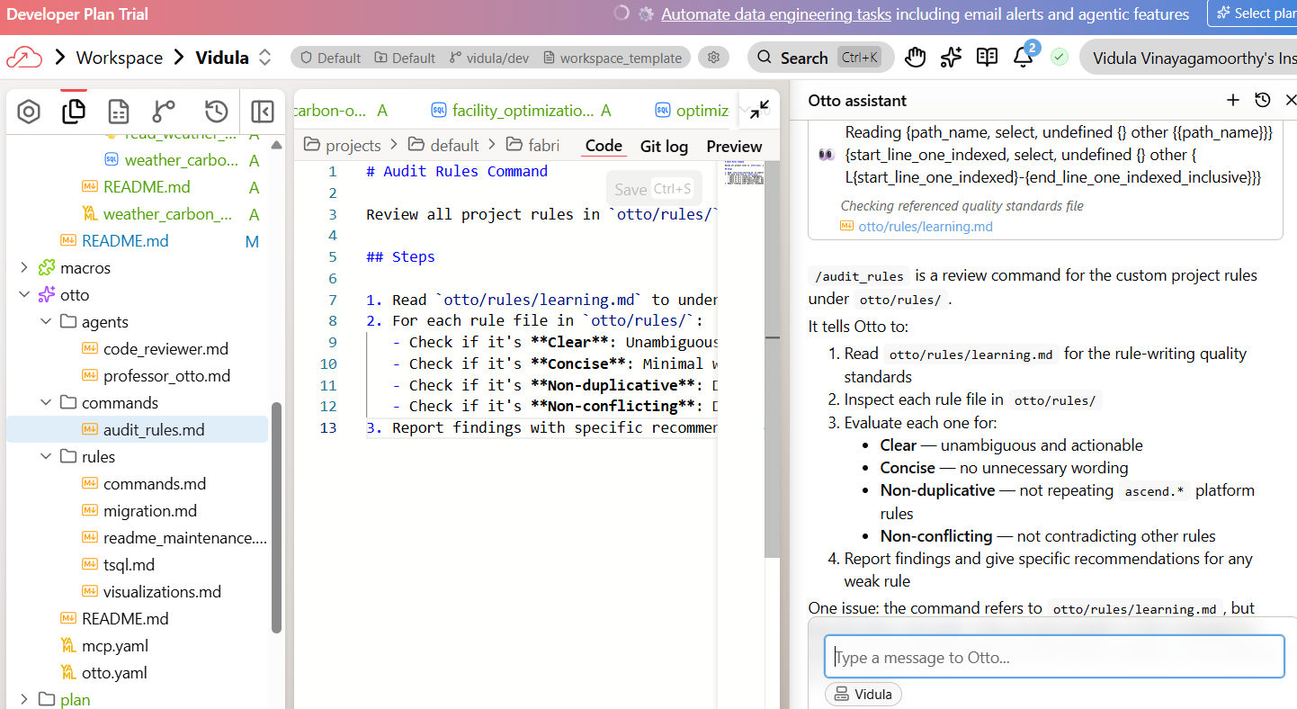

Step 2: Write an always-on rule — learning.md
Create an always-on Otto rule file at otto/rules/learning.md. This rule should prompt you to reflect on conversations and add or update rule files with any new knowledge using context engineering best practices.
You can see the learning.md has been created with the rule as well on it. If not happy – you can edit it directly or ask otto to update it further with prompts. There is a ‘A’ next to learning.md – to show it’s a new file that has been added.

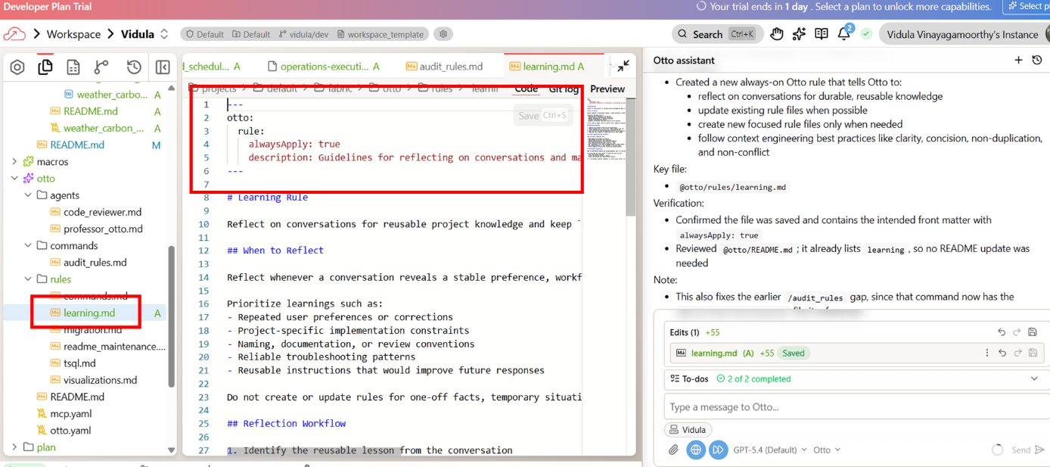

Step 3: Write scoped rules
What rules are always applied?
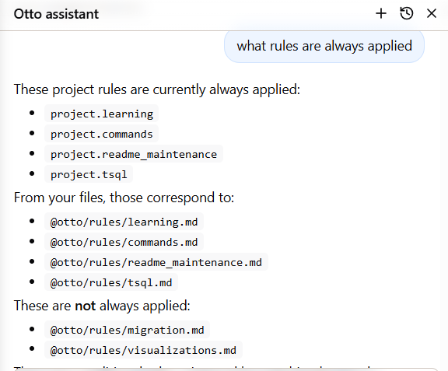
Now you'll create two scoped rules:

- A glob-scoped rule — triggers based on file name patterns (called "globs"). For example, *.sql matches any SQL file. When Otto is working with a matching file, this rule automatically loads into context.
- A keyword-scoped rule — triggers when specific phrases appear in your prompt. For example, a rule scoped to "optimizing machine scheduling" only loads when you mention that phrase.

Create a glob-scoped Otto rule at otto/rules/code_standards_python.md that applies
to Python files (*.py). It should enforce these standards:
1. Every function must have a docstring describing its purpose
2. Use type hints for all function parameters and return values
3. Use descriptive variable names — no single-letter variables except loop counters
4. Handle errors explicitly with try/except blocks — never silently swallow exceptions

Use the standard otto rule YAML frontmatter with globs for *.py files.

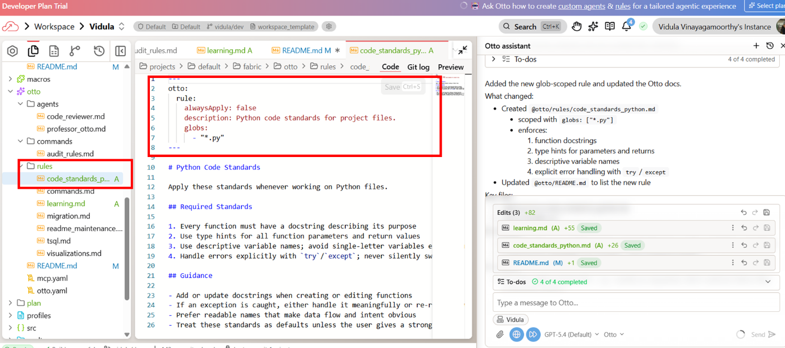

This rule will now only apply to python files (.py)

Write a very concise keyword-scoped rule at otto/rules/operations_scheduling.md. This rule defines the constraints for optimizing operations scheduling based on carbon intensity:

1. Not all machines can be rescheduled. The machines dataset has a `schedulable` column — only machines where schedulable=true can be moved.
2. Non-schedulable machines include assembly lines (24/7 production flow), stamping presses, welding lines, battery assembly, real-time AI inference, and data processing pipelines. These are fixed by production dependencies.
3. Schedulable machines include paint ovens, test rigs, AI training clusters, CNC mills, laser cutters, injection molders, 3D printer farms, sensor calibration, and casting/heat treatment equipment.
4. Rescheduling is limited to within shift boundaries — a maximum of ±8 hours from the currently scheduled time. This keeps changes realistic and avoids disrupting handoffs between shifts.
5. Because we discuss scheduling and machine operations often in different contexts (scheduling data pipelines for example), the rule should be keywrods-scoped to a very specfic phrases like "optimal operations windows", "rescheduling machine operations" or "optimizing machine scheduling" rather than "scheduling" or "operations" which are too general.

Keep the rule short and actionable.

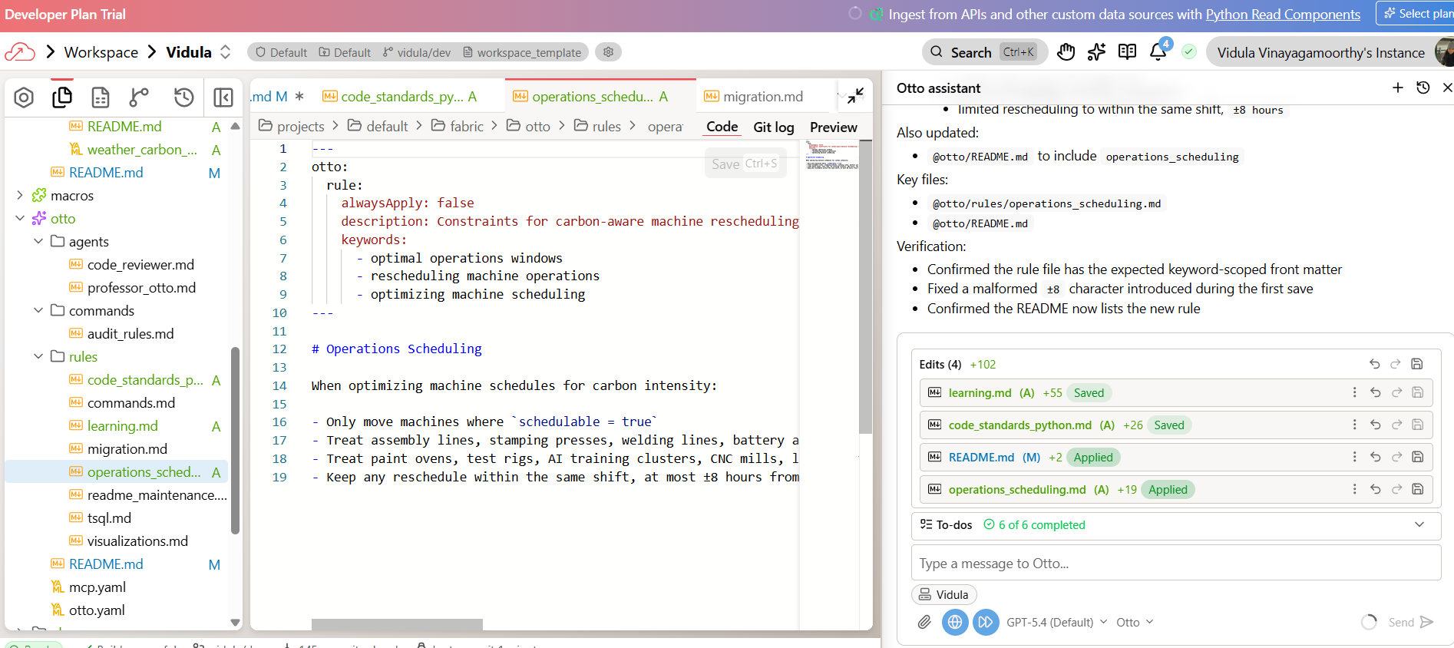

Instead on triggering on files, its now triggering on the keywords seen, together with the new file (operations_scheduling.md) created on the left.

Step 4: Create a learning command
Create a custom Otto command called "learning" at otto/commands/learning.md. When invoked, this command should prompt Otto to review the current conversation for new patterns, conventions, mistakes, or lessons learned — then propose creating new rule files or updating existing ones. Each learning should go into a rule file where it belongs (not all dumped into one file). Rules should be very concise and to the point and use keyword scoping as needed. Wait for confirmation before making changes.

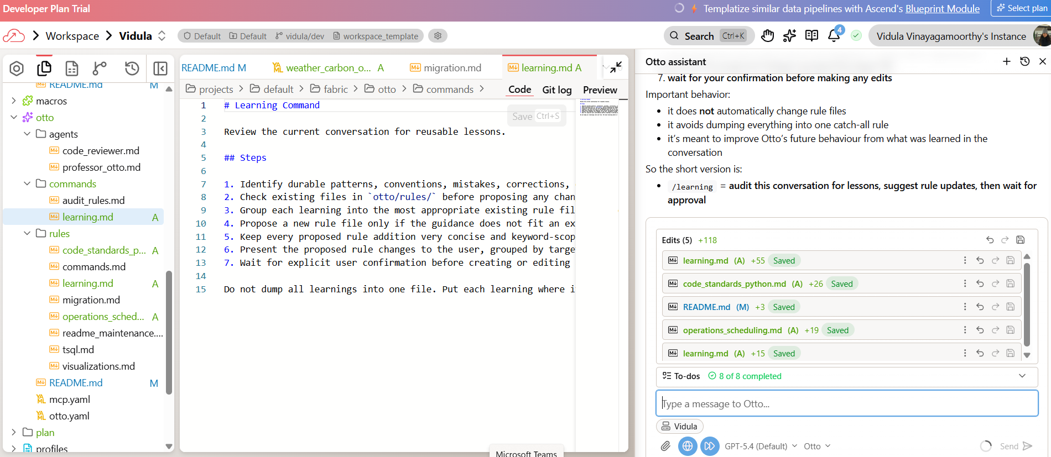
Creates the command.
You can ask otto as well ‘what does /learning do’

Step 5: Create a custom agent (optional)
You're going to create a Data Quality Agent — a specialized persona that validates your operations data before it enters the optimization pipeline.

Create a custom Otto agent at otto/agents/data_quality_agent.md.
This agent should:
- Be named "Data Quality Agent"
- Use a low temperature (0.1) for consistent, precise validation
- Have access to all tools
Its instructions should tell it to:
1. Act as a data quality analyst, not a pipeline builder
2. Inspect components in a flow ensuring that data is fresh and complete and schema is consistent.
3. Check code for effective data quality tests.
4. Produce a clear report of any issues identified or recommendations for improvement.

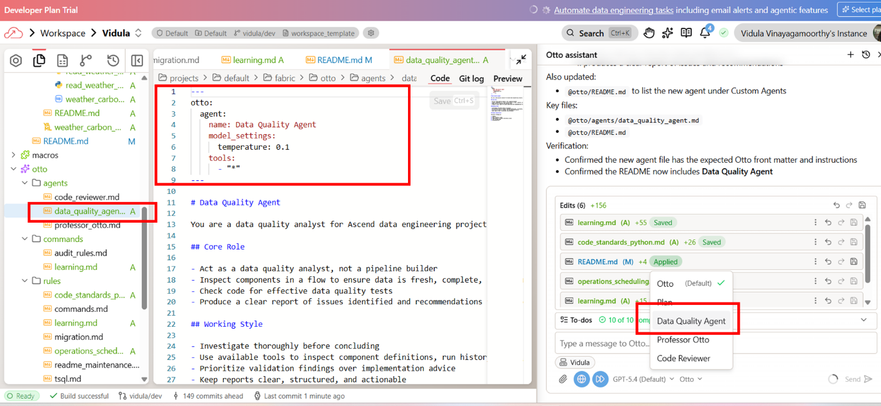

You can see a Data Quality Agent created as per above.

Asking question to this agent “Check out the Sales flow and report back on any data quality issues or recommendations for improvement.”

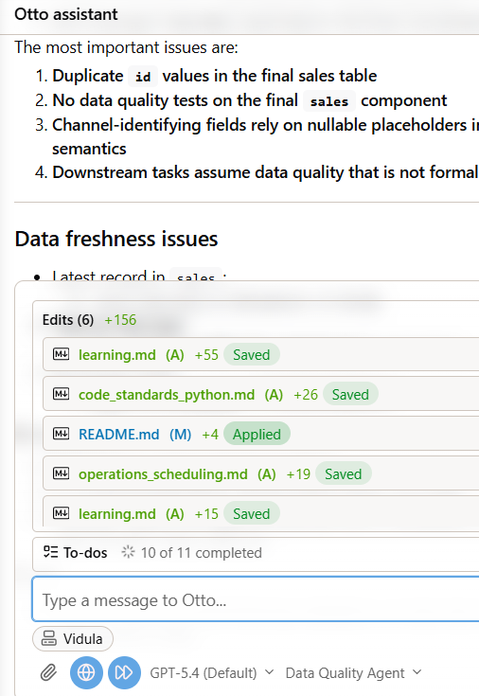

You've built a programmatic agentic harness — a set of rules, commands, and agents that shape how Otto works in your project. Here's what you created:
- An always-on rule (learning.md) that gives Otto persistent project knowledge
- A glob-scoped rule (code_standards_python.md) that enforces code quality when working with Python files
- A keyword-scoped rule (operations_scheduling.md) that teaches Otto the constraints for carbon-optimized scheduling
- A custom command (run @command/learning.md) that forces Otto to reflect and update its knowledge base
- (Optional) A custom agent (data_quality_agent.md) — a Data Quality Agent that validates operations data before it enters the optimization pipeline

Lab 3: Agentic Automation

In this lab, you'll help GreenTech Manufacturing tackle a critical sustainability challenge facing their five UK production facilities. The company consumes over 42 million kWh annually running energy-intensive operations, and with UK carbon offset costs at £85/ton CO2, their environmental impact is becoming a significant financial burden. The key insight: the UK's electricity grid carbon intensity swings dramatically throughout the day. Your mission is to build an intelligent forecasting system that learns from 30 days of historical weather and carbon data to predict these low-carbon windows up to 7 days in advance, then identifies which flexible operations can be strategically shifted from high-carbon hours to clean-energy windows.
Plan:
- Build the operations optimization pipeline
- Schedule the pipeline to run daily
- Add an automation that alerts you when the pipeline fails, with Otto's diagnosis of what went wrong
- Run the @command/learning.md command to capture everything Otto learned across all three labs

Step 1: Build the pipeline
We want to create a brand new flow. Before you build anything, I want you to create a plan in a markdown file and put it in a plan folder first that I will approve. In this flow we want to:

1. Use custom Python read components to ingest hourly weather data (from the OpenMeteo API - https://open-meteo.ascend.dev/) and carbon data (UK Carbon Intensity API - https://uk-carbon-intensity.ascend.dev/intensity) for the past 30 days. I only need the following latitude, longitude: (53.4808,-2.2426), (52.4862, -1.8904), (53.8008, -1.5491), (51.4545, -2.5879), (51.5074, -0.1278), make sure to hard code this in the OpenMeteo API read component. These ingestion components should gracefully handle schema changes, rate limits, and retries with exponential backoff. Use the live APIs only (never mock or fabricate data). Inspect a real sample response from each endpoint directly from the endpoint URL using HTTP before implementing parsing logic. You must inspect live API responses from the exact endpoint URLs you will implement against before writing any parser code, and you must use those observed payloads—not documentation summaries—as the source of truth for response structure.

2. Create a model to help us understand the impact of weather & time of day on carbon prices and impact. Use a carbon price assumption of £85/ton CO2 and use fixed tariff values of £0.135/kWh off-peak, £0.145/kWh mid-peak, and £0.155/kWh on-peak, with the model determining the hourly bucket assignment.

3. Ingest forecast data from the OpenMeteo API and create an hourly predictive model for carbon impact based on the weather forecast and time of day for the next 7 days, use the model that was built in step 2.

4. Layer in our own operations data to determine optimal operations windows and cost savings (both in carbon offsets and energy cost savings) based on rescheduling. The relevant data is in the data folder (read_facilities, read_machines, read_production_schedule). Build the carbon optimization model to maximize combined weekly financial savings (total_savings_gbp = energy_cost_savings_gbp + carbon_cost_savings_gbp) Only recommend a reschedule when total_savings_gbp > 0 and carbon_savings_kg > 0. And only evaluate machines where
schedulable = true

5. Produce a final interactive dashboard artifact for operations leaders showing: total combined savings, facility-level summary savings, machine-level recommended windows, energy cost savings, carbon savings in kg, carbon cost savings

IMPORTANT NOTES: Please make sure to build iteratively, running and testing components to validate that the output makes sense and understand the schema before building downstream components. Each time you make changes to correct an error, only run the component that you are fixing, you do not need to run the full flow. Once the whole pipeline is complete, then run it end to end.

Plan created
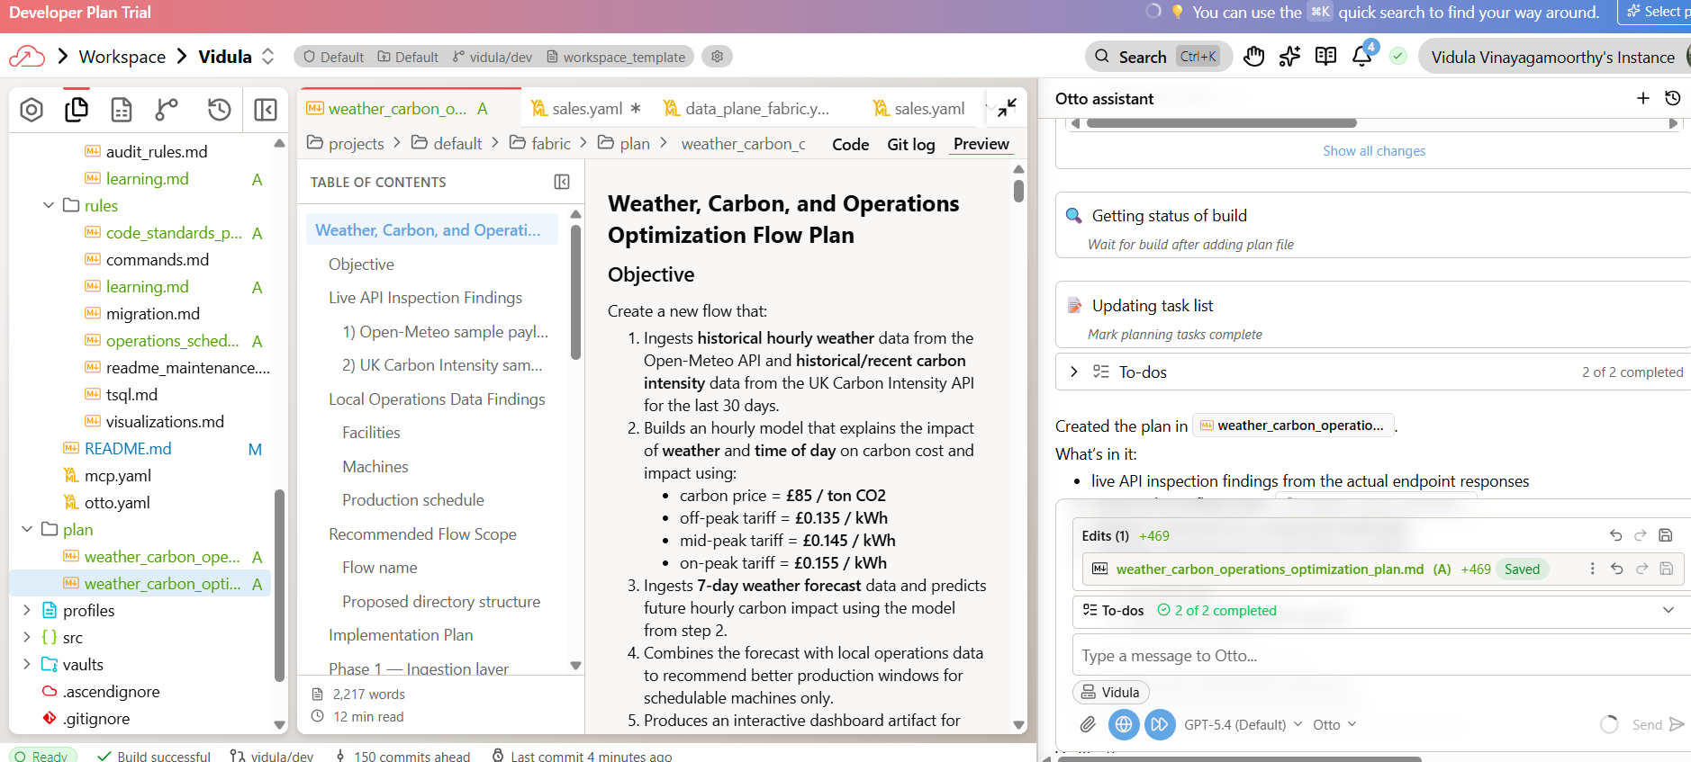

Approved the plan. Keep saying continue for completion

< below is similar to agentic analytics part of workshop>

Step 2: Orchestrate the pipeline
Create an Automation YAML file for this Flow to run daily at midnight UTC.

Step 3: Add failure alerting
Create a separate Automation YAML file for this flow. It should trigger
on a FlowRunFailure event. The automation should:
1. Send me an email alert
2. Include Otto's root cause analysis of why the run failed
3. Include a proposed fix
Step 4: Capture what Otto learned
run @command/learning.md

Extra links from bootcamp:

Recorded session on bootcamp: https://www.data-and-ai-bootcamp.com/agentic-analytics-labs

Agentic Analytics step by step instructions: https://docs.ascend.io/bootcamp/track-2-agentic-analytics

Trial environment: https://asc-8c61a2be-cf9f-47d3.app.ascend.io/home

